Chapter 13, Problem 82.

Use PSpice to find V₁, V₂, and I_{o} in the circuit of Fig. 13.141.

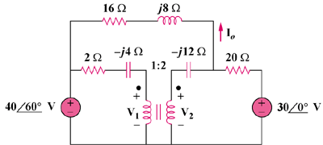

Figure 13.141
For Prob. 13.82.

